**KENNETH DIKE LIBRARYUNIVERSITY OF IBADAN LIBRARY GUIDE**







**Dr. Mercy Ariomerebi Iroaganachi**

**University Librarian**

**LIBRARY MANAGEMENT TEAM**





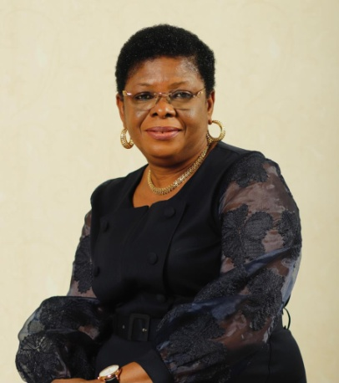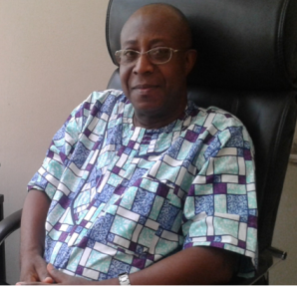

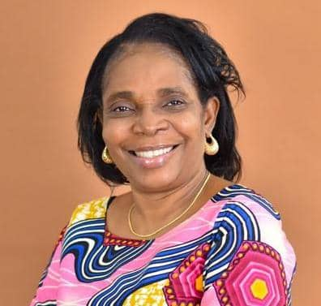

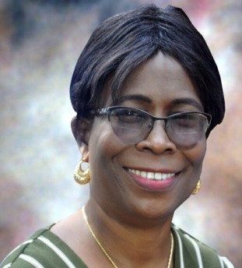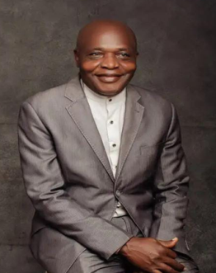

**CONTENTS**

Introduction ……………………………………………………………..6

General information ……………………………………………………..8

A Tour of the Main Library …………………………………………….12

College/Faculty/Institute/Centre Libraries ……………………………..14

Library Resources ……………………………………………………….15

Exploitation of Library Resources ………………………………………24

Library Services/Facilities ………………………………………………25

Organization of Materials ……………………………………………….27

Picture Gallery …………………………………………………………..29

**INTRODUCTION**

The University of Ibadan library reservesthe responsibility acquire, organise and provideaccessible, quality educational resources(books, journals, reports, monographs, electronic-based materials etc) and effective services to support the teaching, learning and research mandates of the institution. Pursuant to the actualization of this responsibility, the University maintains a three tier library system with Kenneth Dike Library (KDL) as the main library and central hub of the system. Other libraries in the system are the Latunde Odeku Medical Library which is located about eight (8) kilometers away at the College of Medicine and 26 Faculty, Departmental/Institute libraries.

Over the years, the physical collections of these libraries have grown and are still growing such that the extant aggregate holding of learning resources in the system is estimated at well over two million volumes. These consist of books, journals, dissertations, technical reports and monographs including materials of historical nature such as the Africana collections.

The University Library deploys modern technologies and analogue resources in the provision of hybrid library services to meet the exceptional needs and aspirations of its sophisticated clientele. Thus, in addition to the physical collections, the Library subscribes to a number of electronic databases and curates many other relevant sources to meet specific academic needs of the University such as ProQuest, Research4life and Emerald. Access to some of the databases is Internet Protocol (IP) address controlled. This means that they can be accessed by logging into the University network while on campus.Outside the campus, users can access them through login details which the Library provides and moderates.

Also, routine activities and sections of the Library are automated such that the bibliographic records of the physical collections are held in digital formats and easily retrievable, thereby ensuring access to the Library resources anytime, anywhere. The University of Ibadan Integrated Library System (UIILS) is the Library management software deployed for managing the Library activities. The Library catalogue can be accessed from the comfort of offices, classrooms and homes anytime as long as there is internet connectivity. Digitization of the collections in the libraries especially the rare materials is still ongoing,

It is my earnest desire that you take full advantage of the robust Library System in the University and maximize the use of its resources for your academic endeavours.

I welcome you to the University of Ibadan Library System and to your Era of unlimited academic success as you sojourn in the University.

***Dr. Mercy Iroaganachi***

***University Librarian***

**GENERAL INFORMATION**

**HOURS OF OPENING**

**During Session**

Monday – Friday 8.00am – 10.00pm

Saturday 8.00am – 1.00pm

Sunday 5.00pm – 10.00pm

**Semester Break and Long Vacation**

Monday – Friday 8.00am - 6.00pm

Saturday 8.00am - 1.00pm

**Public/National Holidays** Library Closed

*Warning signals are sounded thirty and fifteen minutes before closing time. All desk transactions end fifteen minutes to closing time. The library is closed on National Holidays. Notices to this effect are pasted on the library bulletin boards.*

**Library Website/E-mail/Twitter/Facebook/LinkedIn Addresses:**

**Website**: <http://www.library.ui.edu.ng/>

**Facebook**: <https://www.facebook.com/LibraryKDLUI>

**Twitte**r: @LibraryKDLUI

**LinkedIn**: Kenneth Dike Library

**Library e-mail**: [librarykdl@mail.ui.edu.ng](mailto:librarykdl@mail.ui.edu.ng)

**University Librarian’s e-mail:** [universitylibrarian@mail.ui.edu.ng](mailto:universitylibrarian@mail.ui.edu.ng)

**PostalAddress**: Kenneth Dike Library

University of Ibadan

Ibadan, Oyo State Nigeria.

**Admission to the Library**

The library is open to all ‘members’ of the University community, and also open to Senior Staff of the University College Hospital, Ibadan and Alumni/Alumnae of the University. Anyone else with cogent reasons for using it may also be admitted to use the library for study and reference purposes only. In all cases, the claims of scholarship and research are given first consideration. It is also open to staff and students of other Nigerian universities who are especially introduced by their respective University Librarians.

**Registration**

1. All students and staff of are required to fill the library registration form and also produce two passport photographs. This will lead to an issuance of a “library identification card” for members of the University system only. This card is valid for the duration of a programme.
2. Persons who wish to make regular use of the library and who are not eligible under the terms above must make personal application to the librarian for such permission. Demands on library facilities from within the university make it increasingly necessary to grant this only in exceptional cases. The claims of scholarship and research are given preference.
3. Each reader is registered with the privilege of borrowing.
4. Books must be returned immediately when on recall.
5. Books may not be taken away from Ibadan without the prior permission of the university librarian.
6. All books borrowed from the library should be returned before a reader goes on leave or leaves Ibadan.
7. Reader’s identification cards are not transferable and all borrowing and renewals must be made in person.
8. All users must take along their library identification card which must be produced upon demand in the library.
9. Readers must submit their bags, books or any materials they are carrying while leaving the library for checking at the check points.
10. Silence is requested in and around the library. Use of cell phone is not allowed in the library; therefore, all cell phones must be put off as readers enter the library.
11. Edibles of all kinds are prohibited in the library (except in the coffee room).

**Borrowing**

1. Identify the book you need from the shelves after consulting the card catalogues or OPAC.
2. Online borrowing of a book, already identified by a user can be done online from any location.
3. Visit the Circulation desk to physically collect the book that was borrowed online.
4. ***For manual borrowing:*** 
   1. identify the book you need from the shelves after consulting the catalogues;
   2. ensure that the book is in good condition and that no pages are missing before taking it to circulation desk;
   3. show your library identification card to the library assistant;
   4. ensure that the book is properly charged out;
   5. by filling the loans cards from book pocket;
   6. ensure that the date due slip is stamped correctly to avoid embarrassment at the check points;
   7. ensure that the record of the loan is properly entered in your account on the computer system.
5. Do not allow others to use your library identification card.

**NOTE**: The book is now in your keeping. It is important that the “date-due" slip does not drop out of the book.

**Number of Loans Permitted for Readers**

The maximum number of books permitted for a loan period is four (4) for undergraduates, six (6) for post graduate/research students and ten (10) for academic or faculty staff.

**Duration of Loans**

The normal duration of loan is two weeks for undergraduate and one month for research students, Academic and Non-teaching staff. However, a loan may be renewed on application for one further period as long as no other user requests for the material. After that, it must be returned. Academic staff with special reasons are requested to state clearly the length of a loan period required if they desire to use the material beyond the stipulated time.

**Returning of books**

Books should be returned before or on the due date to the Lending Desk at which they were charged out. Readers must ensure that the Assistants physically receive the books from them. Books borrowed must be returned in good condition.

**Overdue Notices/Fine**

The only notice of due date is the date imprinted in the transaction slip and stamped in the date due slip inside the book at the time of loan. However, a first notice that a book is overdue for return is sent a week after due date. After this, another notice may be the final notice after which it is assumed that the book is lost and the library will demand replacement.

Fines at the rate of Fifty Naira (N50.00) per book per day must be paid for the period a book is overdue. Books lost or damaged should be reported immediately and paid for at the circulation desk. All cases of stealing, mutilations or defacing of books will be regarded as serious offence.

**Holiday Loans**

Readers resident in Ibadan can apply to the University Librarian through the Circulation Librarian for book loan at usual loan periods.

**Inter Library Loans**

Required item(s) not held by the library can usually be obtained for readers from another library. All inter library loans requests are to be directed to the Reference Librarian, who will interface with a sister library and notify the reader on the receipt of the materials. The term will then be treated as normal loan at the circulation desk.

***Circulation Desk (See Picture 2 in the Gallery)***

**Carrels**

Limited number of carrels in the library is reserved primarily for graduate students. Application may be made to the University Librarian through the Reference Librarian for usage for an assigned period.

**Lost but found items**

Lost but found items are held at the circulation desk. Identifiable items are returned to the owners while all unclaimed items are forwarded to the information desk.

**Library Rules and Regulations**

* No eating or drinking in the library
* Perfect silence is required in the library
* Mobile phones can be used in **SILENCE MODE ONLY**
* No reservation of seats
* No group discussions **EXCEPT IN THE CHAT ROOM**
* Users are to comply with rules governing computer usage
* Stealing is a serious offence
* Library identification cards should be tendered at the library Check points
* Library identification cards are not transferable
* Users are expected to collect bag tags at the check point when coming into the library
* Do not leave valuables in your bag when checking in
* Bags should be kept in the cloak room
* All library materials should be properly borrowed before taking them out of the library
* Smoking is not permitted anywhere in the library.

**Theft or Mutilation**

Attempted theft or mutilation of any library materials is a serious offence. It attracts heavy penalty from the management of the library, and the university authority.

**TOUR OF THEMAIN LIBRARY (KENNETH DIKE LIBRARY)**

There are two main entrances to the main library, which are available to readers. There are two security points in the library for the protection of the library properties. Personal belongings and bags are not allowed inside the reading area and should be deposited in the area reserved for their safekeeping in the **Cloak Room**. Bags and other valuable items are kept at owner’s risk.

***Main Entrance – Porters’ Lodge (See Picture 1 in the Gallery)***

**Ground Floor-East**

The Library operates a 24-Hour reading system by providing a space to cater for the need of users. The space is opened 24 hours for users from Monday to Sunday and on public holidays. The 24-hour reading space is located on the ground floor of the library. The space is accessed via the third entrance to the library once the main library closes. The space is for reading only, and access to the main library and its services from the 24-hours space is not available after closing hours.

**Ground Floor – West**

This floor houses:

* The Reception
* Circulation Desk
* Online Public Access Catalogue (OPAC)
* Exhibition Gallery
* Photocopy Room
* Reference/Research Library, Africana and Public Ordinance (PO) Sections
* Carrels
* E-classroom
* Cataloguing Section
* Digitization Chamber

**Basement of the Library**

The basement of the library houses:

* Serials Section
* Carrels
* Staff Officesfor the Deputy University Librarians
* Nigeriana
* Accounts Unit
* Coffee Room
* Bindery

|  |  |  |
| --- | --- | --- |
| **FIRST FLOOR** | | |
| **EAST** | **LANDING** | **WEST** |
| E-Research Library | Chat Room | Systems Unit |
| **SECOND FLOOR** | | |
| Literatures, Arts, Economics, Social Science Materials | Collection Development Division | Education, Librarianship, Medical Sciences, Agriculture |
| **THIRD FLOOR** | | |
| Science, Technology, Military Science, Naval Science | University Librarian’s Office | |
| **FOURTH FLOOR** | | |
| Closed Access | Arabic Books and Manuscripts Collection | |

***Note****: The Closed access collection of the library contains books reserved to be used in-house only. The idea of closed access is to meet the information needs of users who are unable to find needed information materials in the open access library shelves.*

**COLLEGE/FACULTY LIBRARIES**

**College Libraries**

* Latunde Odeku Medical Library is located in the College of Medicine about 8kms away from the Main Campus.
* School of Business Library: This is located at the Ajibode extension of the University of Ibadan Campus. It is basically a postgraduate library.

**Faculty Libraries**

* Agriculture/Renewable Natural Resources Library
* Faculty of Arts Library
* Faculty of Clinical Sciences Library
* Faculty of Education Library
* Faculty of Law Library
* Faculty of Pharmacy Library
* Faculty of Public Health Library
* Faculty of Science Library
* Faculty of Technology Library
* Faculty of The Social Sciences Library
* Faculty of Veterinary Medicine Library

**Institutes/Centre Libraries**

* Africa Regional Centre for Information Science (ARCIS) Library
* Institute of African Studies Library
* Institute of Education Library
* Institute of Peace and Strategic Studies (IPSS) Library
* WORDOC Library

**LIBRARY RESOURCES**

**Print Resources**

The University library system has about two million volumes of books and 8,000 journal titles. There are two main categories of print collections - circulating and non-circulating collections.

* ***Circulating Collections:*** These collections can be found on the 1st Floor East, 2nd Floor West, 3rd Floor East and 4th Floor West**.** The books on these floors can be borrowed.
* ***Non-Circulating Collections:*** These are Reference,Serials, and Closed Access materials. They cannot be borrowed.

**Africana Collections**

The library has a large and in many ways unique reference collection of historical materials on Africa, West Africa and Nigeria. These materials date back to the colonial and precolonial era. Some are so rare that they are only available in this library.

**Nigeriana Collections**

This collection is a fully inter-disciplinary comprising all subjects available in all the faculties of the University. This collection is highly robust, containing all locally published books i.e. books published in Nigeria by Nigerians. It is well organized using the library of Congress (LC) Classification Scheme. The shelves are well labeled for easy access.This section is very important to all category of students and researchers who need local materials for their academic endeavors. The books are strictly non loanable. They are available for access and consultations at the unit situated in the basement below the research library close to the Serials section.

**Arabic Books Collection**

This collection contains materials that are fundamental to the study of Nigerian and African history as well as general resources relating to the Islamic discipline. In particular, there are many original Arabic manuscripts of local provenance. These are supplemented by an extensive microfilm files of Arabic writings collected from several private Libraries in West Africa. The manuscripts are located in the west wing of the fourth floor of the Undergraduate Section and the Research Library.

**Maps Collection**

The Library has a collection of more than ten thousand maps. Special emphasis is on maps of Africa, particularly West Africa and Nigeria. The map collection is located in a special map room on the fourth floor of the main (Undergraduate) building where they can be consulted. Atlases are however housed in the Research Library.

**Manuscripts Collection**

The Library has made special efforts to develop a collection of private papers and manuscripts particularly relevant to Nigerian studies. In this regard, it has been -fortunate in acquiring the papers of many eminent Nigerians and persons connected with Nigerian history. Among these are the papers of the father of Nigerian Nationalism, the late Herbert Macaulay (1864-1946) whose vast collection of assorted political diaries, business documents, photographs and personal papers of all kinds numbering several thousand individual items, making it the most significant collection of private papers in the Library.

Others include; the private papers of the late Bishop S.C. Phillips, a one - time Bishop of Ibadan Diocese and Vicar- General in the Anglican Church, the Egba Documents presented by the late Alake of Abeokuta, Sir Ladapo Ademola, the photographs, journals and, clippings of E.R. Jerrim (1888-1962), an associate editor of *West Africa Newspaper* from 1921 till 1939; the private papers of Chief Akinpelu Obisesan (1887-1963); Rev. E.M. Lijadu; Rev. I.O. Ransome Kuti, Apostle J.O. Ositelu, Mr. W.F. Sesan and others. In recent times, many of these private donations go to the relevant faculty libraries mainly at the request of the donors.

**Government Publications**

These includes acquisitions from the Federal, regions and state governments of the Federal Republic of Nigeria as well as publications of various inter-government organizations (and their specialized agencies), such as UN, OAU, ECOWAS etc. Such as documents of UN 1954-1964 and Hansard (G.B)1803-1908.

**Publications Ordinance/Legal Deposit**

This is a collection of materials acquired by legal deposit. In 1950 it became a legal requirement for publishers throughout the country to deposit two copies of their books, journals, pamphlets, gazettes, sheets of music, maps, plans, etc. with the Kenneth Dike Library,as it was designated the national depository for Nigerian publications. For twenty years University of Ibadan Library remained the national legal depository for the country. However, the Library cannot claim to have a complete collection of legal deposit or Publications Ordinance materials as from 1950 till date.

First, the establishment of regional governments occasioned the repeal of the 1950 Ordinance by all three regional governments and substituted with local publications laws in 1955, 1956.and 1964 for the Eastern, Western and Northern regions respectively.The Eastern and Western regional publications laws however still named the University of Ibadan Library a legal depository for publications emanating from their regions. But the Northern Region 1964 publications law gave this privilege to the Ahmadu Bello University Library. Irrespective of the 1964 publication laws, publishers in the Northern Region still generally felt compelled to uphold the injunction of the 1950 Ordinance.

The situation changed with the creation of States in 1967 and in June 1970, the National Library Decree (Decree No. 9 of 1970) was passed which effectively transferred the role of legal deposit from the University of Ibadan Library to the National Library of Nigeria in Lagos. Thus, the national bibliography of Nigerian Publications, hitherto published by the University of IbadanLibrary has since 1970, been published by the National Library of Nigeria. Howbeit, the 1970 Decree mandated that the University of Ibadan Library receive one copy of each legal deposit material sent to the National Library, and many publishers still send two copies of their publications to UI Library purely on complimentary basis. Thus, in spite of vicissitudes of the time, the University of Ibadan Library collection of government publications and other legal deposit materials is fairly comprehensive, very rich in unique items, and valuable for research.

**Theses Collection**

A collection of theses submitted for the award of the Ph.D degree at Ibadan University is kept in the Theses Room. Theses can be consulted on request at the control desk of the Research Library.

**Reference Collection**

Reference Section of the library is located at the ground floor West extension of Kenneth Dike Library. It was established in 1969 to cater for the expansion of the university library system. The Reference Section is also referred to as Research Library where post graduate students and staff could use reference materials for research purposes. Specifically, this section attends to day-to-day information queries of the postgraduate students and staff of University of Ibadan. The use of the Research Library is also extended to external researchers based on referral letter. Collections in this section include; Theses and Dissertations, Dictionaries, Encyclopedias, Atlas, Maps, Yearbooks, Africana materials, Proceedings, Calendars, Gazettes, Arabic manuscripts, Newspapers,Indexes and Abstracts among others which serve the specific information needs of library users. The Reference Section has a seating capacity of 400. There is regular supply of electricity supply to the section through alternate sources of power generation such as inverter and solar. ***(See Picture 3 in the Gallery)***

**Newspapers**

The Library subscribes to some important Nigerian newspapers. These are displayed in the General Reading Room. One month issues are kept for consultation in the Reserved Book Room while the back issues are kept in the Africana Section of the Research Library.

**The Systems Unit**

The systems unit of Kenneth Dike Library is divided into three (3) sub-units; namely: the technical sub-unit; digitization sub-unit; and the electronic resources sub-unit. The collective responsibility of all these sub-units is to set up a sustainable platform for Information Technology (IT) implementation in the entire University of Ibadan Library system, particularly in respect of rendering effective information services delivery to the users of our great Library. ***(See Picture 4 in the Gallery).***

**ELECTRONIC RESOURCES**

The Library subscribes to and provides access to electronic resources and is committed to increasing its e-resources, such as e-books and e-journals.

**List of available electronic resources in Kenneth Dike Library**

**LOCAL AREA NETWORK (LAN) BASED E-RESOURCES**

|  |  |  |  |  |  |
| --- | --- | --- | --- | --- | --- |
|  | ELECTRONIC RESOURCES | URL ADDRESS | USER NAME | PASSWORD | REMARK |
| 1 | TEEAL | Available in the computer lab Agricultural& Forestry Library | LAN | LAN | Access over 200 essential agricultural journals. No internet connection required. The subject area covers agricultural engineering, Agriculture, Animal science/ Veterinary medicine/, Biology/ Genetics, Biotechnology/ Applied microbiology, Chemistry/ Biochemistry/ Biophysics, Economics/ Social science/ Development, Entomology/ Pest control, Environment/ Ecology/ Natural resources, Fisheries/ Aquatic science, Food science/ Nutrition, Forestry, Human/ Medicine/ Physiology, Plant science/ Soil science. |
| 2 | Kenneth Digital Library | Localhost/gsdl?uq=6318000 | Restricted Access | Restricted Access | Covers all subject areas and the resources are only available on the Library’s Intranet. |

**DATABASE/E-RESOURCES**

|  |  |  |  |  |  |
| --- | --- | --- | --- | --- | --- |
|  | ELECTRONIC RESOURCES | URL ADDRESS | USER NAME | PASSWORD | REMARK |
| 3 | OPAC (Online Public Access Catalogue) | http:10.0.43.3.80 | Open Access | Open Access | The OPAC is a catalogue of all the materials in the Kenneth Dike Library. It contains all the bibliographic records of books, journal, etc. in the Library. |
| 4 | Institutional Repository | http://ir.library.ui.edu.ng/ | Open Access | Open Access | Cover all subject areas. It contains research output of the University staff. Its content includes lecture notes publications, theses, conference proceedings, inaugural lectures etc. |
| 5 | PROQUEST | search.proquest.com | IP-regulated | IP-regulated | All Subject Areas. Books and journal articles |
| 6 | EMERALD | <http://emeraldinsight.com> | IP-regulated | IP-regulated | Contains Journals & Books in the following subject areas: Accounting & Finance, Economics, Education, Engineering, Health & Social Care, HR & Organizational Behavior, Information & Knowledge Management, Library & Information Science, Management Science & Operations, Marketing, Property Management & Built Environment, Public Policy & Environmental Management, Sociology, Strategy, Tourism & Hospitality, Transport |

|  |  |  |  |  |  |
| --- | --- | --- | --- | --- | --- |
| 7 | EBRARY | <http://site.ebrary.com/lib/ibadan> | IP-regulated | IP-regulated | EBOOK |
| 8 | SPRINGER | link.springer.com | IP-regulated | IP-regulated | Providing researchers with access to millions of scientific documents from [journals](http://link.springer.com/search?facet-content-type=%22Journal%22), [books](http://link.springer.com/search?facet-content-type=%22Book%22), [series](http://link.springer.com/search?facet-content-type=%22BookSeries%22), [protocols](http://link.springer.com/search?facet-content-type=%22Protocol%22) and [reference works](http://link.springer.com/search?facet-content-type=%22ReferenceWork%22). It covers the following subject areas: [Architecture & Design](http://link.springer.com/search?facet-discipline=%22Architecture+%26+Design%22)[Astronomy](http://link.springer.com/search?facet-discipline=%22Astronomy%22), [Biomedical Sciences](http://link.springer.com/search?facet-discipline=%22Biomedical+Sciences%22), [Business & Management](http://link.springer.com/search?facet-discipline=%22Business+%26+Management%22) ,[Chemistry](http://link.springer.com/search?facet-discipline=%22Chemistry%22), [Computer Science](http://link.springer.com/search?facet-discipline=%22Computer+Science%22), [Earth Sciences & Geography](http://link.springer.com/search?facet-discipline=%22Earth+Sciences+%26+Geography%22), [Economics](http://link.springer.com/search?facet-discipline=%22Economics%22), [Education Language](http://link.springer.com/search?facet-discipline=%22Education+%26+Language%22), [Energy](http://link.springer.com/search?facet-discipline=%22Energy%22), [Engineering](http://link.springer.com/search?facet-discipline=%22Engineering%22), [Environmental Sciences](http://link.springer.com/search?facet-discipline=%22Environmental+Sciences%22), [Food Science & Nutrition](http://link.springer.com/search?facet-discipline=%22Food+Science+%26+Nutrition%22), [Law](http://link.springer.com/search?facet-discipline=%22Law%22), [Life, Sciences](http://link.springer.com/search?facet-discipline=%22Life+Sciences%22), [Materials](http://link.springer.com/search?facet-discipline=%22Materials%22), [Mathematics](http://link.springer.com/search?facet-discipline=%22Mathematics%22), [Medicine](http://link.springer.com/search?facet-discipline=%22Medicine%22), [Philosophy](http://link.springer.com/search?facet-discipline=%22Philosophy%22), [Physics](http://link.springer.com/search?facet-discipline=%22Physics%22), [Psychology](http://link.springer.com/search?facet-discipline=%22Psychology%22), [Public Health](http://link.springer.com/search?facet-discipline=%22Public+Health%22), [Social Sciences](http://link.springer.com/search?facet-discipline=%22Social+Sciences%22), [Statistics](http://link.springer.com/search?facet-discipline=%22Statistics%22) |
| 9 | WEB OF SCIENCE | Webofknowledge.com | IP-regulated | IP-regulated | Find cover-to-cover indexing of the world’s most important multidisciplinary research, covering scholarly journals, books, proceedings, published data sets, and patents. |

**RESEARCH 4LIFE (ejournals/ebooks)S**

|  |  |  |  |  |  |  |
| --- | --- | --- | --- | --- | --- | --- |
| 10 | AGORA | | **login.research4life.org** | **NIE529** | **99499** | Access to global online Research in Agriculture. The AGORA program, set up by the food and Agriculture Organization of UN (FAO] together with major publisher, enable developing country to gain an access to an outstanding digital Library collection in the field of food ,agriculture, environmental science and related social sciences. |
| 11 | HINARI | | Health Inter Network Access to Research initiative The HINARI program, set up by WHO together with major publishers, enable developing countries to gain access to one of the World’s largest collections of biomedical and health literature. |
| 12 | ARDI | | The Access to Research for Development and Innovation (ARDI) program is coordinated by WIPO together with its partners in the publishing industry with the aim to increase the availability of scientific and technical information in developing countries by improving access to scholarly literature from diverse fields of science and technology. Currently, 17 publishers provide access to around 20,000 journals, books, and reference works for 117 developing countries and territories through ARDI |
| 13 | OARE/GOALI | | Online Access to Resources on the Environment/LAW |
| 14 | JSTOR | | for access through UI net: **http://.jstor.org/logon/** the new token link to register for myjstor account is **http://www.jstor.org/token/bQRVSEcFzQQhUxavQpw9/ui.edu.ng** follow this link to create myjstor account that you can use off and on the campus to access jstor. [this is case sensitive] | IP-regulated & individual registration required | IP-regulated & individual registration required | A journal store with resources on ALL subjects. This resource is IP regulated on campus. 0FF campus access is by the token method that requires registration. Follow the link provided from a computer on a UI Net , and a user’s name and password could be created for individuals which can then be used off campus consequently |
| 15 | IMF E-Library | | [www.elibrary.imf.org/search](http://www.elibrary.imf.org/search) | IP-regulated | IP-regulated | Covers: Business and Economics, Education, Law, Medical, Nature, Political Science, Social Science, Technology and Engineering. |
| 16 | BIOONE | | [www.bioone.org](http://www.bioone.org) | IP-regulated | IP-regulated |  |
| 17 | NATURE JOURNALS | | [www.nature.com](http://www.nature.com) | IP-regulated | IP-regulated | Covers: Biological Sciences, Earth & Environmental Sciences, Physical Sciences and Scientific Community & Society |
| 18 | NEW ENGLAND JOURNAL OF MEDICINE | | <http://www.nejm.org> | IP-regulated | IP-regulated | Medical Specialties & Clinical Medicine |
| 19 | ROYAL SOCIETY JOURNALS COLLECTION | | http://royalsocietypublishing.org | IP-regulated | IP-regulated | [Royal Society Journals Collection](http://rsos.royalsocietypublishing.org/) is an online, fully open access journal. It publishes articles from across the whole of science, engineering and mathematics. It operates objective, and optionally open, peer review. |
| **OPEN ACCESS E-JOURNALS/E-BOOKS** | | | | | | |
| 20 | | DOAJ | <http://www.doaj.org> | Open Access | Open Access | This service covers free, full text, quality controlled scientific and scholarly journals. There are 2411 journals in the directory. Currently, 708 journals are searchable at article level. |
| 21 | | DOAB | <http://www.doabbooks.org> | Open Access | Open Access | Free access E-Books. |
| 23 | | BOOKBOON | <http://www.bookboon.com> | Open Access | Open Access | Free access E-Book |
| 24 | | AFRICAN JOURNAL ONLINE | http://www.ajol.info/ | Open Access | Open Access | African Journal Online (AJOL) is a service to provide access to African published research and increase worldwide knowledge of indigenous scholarship. |
| 25 | | BIOMED CENTRAL | <http://www.biomedcentral> | Open Access | Open Access | BioMed central is a publisher of more than 150 peer-reviewed open access journals. |
| 26 | | BMJ PUBLISHING GROUP | <http://www.bmjjournals.com/subsciption/countries.shtml> | Open Access | Open Access | BMJ Group publishes BMJ (British Medical Journal), a number of journals covering major medical Specialties and a growing number of online and events products for the healthcare profession. |
| 27 | | POPLINE population information online | <http://www.popline.org> | Open Access | Open Access | POPLINE (Population Information online), the world’s largest databases on reproductive health |
| 28 | | Free Pdf | <http://www.freefullpdf.com> | Open Access | Open Access | Covers all subject |
| 29 | | WORLD BANK GROUP | [www.worldbank.org](http://www.worldbank.org) | Open Access | Open Access |  |
| 30 | | E-JOURNALS | <http://www.e-journals.org> | Open Access | Open Access | E-journals are part of the World Wide Virtual library. Provides links to world electronic journals. |
| 31 | | INTECH | http://www.intechopen.com/ | Open Access | Open Access | All Subject Areas especially Sciences |
| 32 | | ERIC | http://eric.ed.gov/ | Open Access | Open Access | ERIC (Education Resources Information Centre) is a comprehensive database containing abstracts of journals articles, reports, curriculum guides, conference proceedings, etc. It covers all areas of education at all age and grade levels. ERIC Documents 1993+ are now freely available online. |
| 33 | | Z-Library | https://b-ok.cc/ | Open Access | Open Access | Covers all subject and users can only download 10 books per day. |

**Restricted Access**

* Must be on the Kenneth Dike Library Network to have Access

**IP Regulated**

* Must be on the University Network to have Access
* Copy the URL Address and paste on the web browser to have access
* **THEN DO YOUR SEARCH**
* Any question contact, eresources@library.ui.edu.ng

**Institutional Repository (IR)**

The Institutional Repository (IR) contains the intellectual outputs of staff of the University. The contents of the UIIR include lecturers’ publications, lectures, and theses to mention but a few. Wider visibility is provided to UIIR through UISPACE available on the University of Ibadan webpage under the Library’s website. It is also accessible through the World Wide Web via the URL (Universal Resource Locator) **ir.library.ui.edu.ng**.

**EXPLOITATION OF LIBRARY RESOURCES**

The library catalogue gives an inventory of what the library has.

1. Manual Card Catalogue: The main catalogue is on the ground floor located in the 24-Hours library service space. It is in two parts the Author/Title Catalogue; the subject catalogue.
2. Online Public Access Catalogue (OPAC). The online public access catalogue is web based and is accessible to users at the Circulation section and anywhere else. There are 10 computer workstations dedicated to the purpose of accessing library holdings. Training on how to search for materials on the shelves through the OPAC is done through students’ orientation in the library.

***Step-by-step guide to accessing KDL OPAC***

1. Connect to the library wifi – i.e. kdlwireless or circulationAP (if within the library) OR
2. Login to <http://ils.library.ui.edu.ng> (outside the library from any smart device)
3. Type 10.0.43.3:8080 on your browser
4. Click on OPAC
5. Search: Materials may be searched using: Author, Title, Subject and Keywords.

**LIBRARY SERVICES/ FACILITIES**

1. **Inter-Library Loan**

The library also assists users in getting documents not available in the library within the country and from outside the country. Request for such can be done through the information desk or through the reference librarian. (This may be treated as inter library loan).

1. **Bindery Section**

The Library has its own Bindery situated in the basement of the Research Library. The Bindery section is responsible for binding all categories of print materials in the library. These include journals, textbooks, worn out books, theses and dissertations of students. The Kenneth Dike Library was given the statutory duty of binding postgraduate Theses and Dissertations emanating from the University. The Library seal and University Logo are, however, imprinted on them after binding. ***(See Picture 8 in the Gallery).***

1. **Document Delivery Services**

Photocopies of journal articles, papers and theses held by the library are allowed for institutions or individuals provided that copyright restrictions do not forbid the reproduction of such materials. Reproductions of materials not held by the library may be obtained from institutions holding them. If requests are made to the reference librarian, a cost is charged to the requesting individual or department.

1. **Electronic Classroom (E-classroom)**

The E-classroom is a multimedia learning facility equipped with 31 workstations; 1 for teacher/instructor and 30 for students. All PCs are networked and internet ready. It is intended for interactive, hands-on training sessions, and is subject to group and individual use (Restricted Access Only).

1. **E-Library (1st Floor West).**

A computer facility that has the capacity to hold 100 PCs with laptop bays suitable for teaching and research. Access to internet and locally held information resources are available. Scanning and colored printing services are also available.

1. **Carrels**

Research carrels are individual study areas located on the 2nd and 3rd floors of the main building and on both floors of the research library. Allocation to senior staff, research workers and postgraduate students is made on request at the control desk of the research library.

**7. 24 hours Library Services**

The Library provides a 24-Hour reading service to cater for the need of users. The space is opened 24 hours for users from Monday to Sunday and on public holidays. The 24-hour reading space is located on the ground floor of the library. It is accessed via the third entrance to the library when the main library closes. The space is for reading only, and is tastefully furnished for the purpose.

**8. The Chat Room**

The need for a library user to have a space to relax and chat with other users in the library cannot be over emphasized. Kenneth Dike Library is poised to aligning with standard best practices in the provision of diverselearning experiences through leisure and other modes. Thus, in a bid to meet up with international standards, the Library created a convenient purpose deigned and attractive physical ambiance for library users to relax and chat while learning. The chat room can conveniently sit thirty five (35) users at a time. The space is fully air conditioned and there is a large TV screen connected to a satellite dish for users’ leisure. It is located on the first floor of the library and is a beautiful and comfortable place to escape to, from the conventional reading space.The chat room is designed with sound proof technology that prevents noise from filtering out to disturb the peace and tranquility of the library. There are rules and regulations guiding the use of the space and users are enjoined to adhere strictly to the rules and regulations, as is strategically displayed in the chat room for user’s perusal.

**ORGANIZATION OF MATERIALS**

The Library of Congress classification scheme is used for organizing the library materials.

**OUTLINE OF THE LIBRARY OF CONGRESS CLASSIFICATION SCHEME**

**Classification Mark Subject**

A General works, Polygrapy

B Philosophy, Psychology

BL-BX Religion

C Auxiliary Science of History

D History: General, Europe, Asia, Africa, Oceania (DT History: Africa)

E-F History: North and South America

G Geography, Anthropology, Folklore, Manners and Customs, Recreation

H Social Sciences

J Political Science

K Law

L Education

M Music, Books on Music

N Fine Arts

P-PA General Physiology and Linguistics, Classical Languages and Literature

PA Supplement Byzantine and Modern Greek

PR-PH Modern European Languages

PG Russian Literature

PJ-PM Language and Literature of Asia, Africa, Oceania, American, Indian Languages

P-PM Supplement Index to Languages and Dialects

PN, PR, RS, PZ General Literature, English and American Literature

PQ, Part 1 African Literature in English, Juvenile Literature, French Literature (includes African Literature in French)

PQ, Part 2 Italian, Spanish, Portuguese

PT, Part 1 German Literature

PT, Part 2 Dutch and Scandinavian Literature

Q Science

R Medicine

S Agriculture

T Technology

U Military Science

V Naval Science

Z Bibliography, Library Science

**LIBRARY MANAGEMENT**

**temiloluwa**

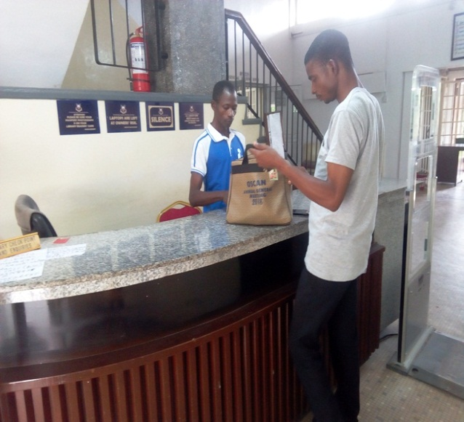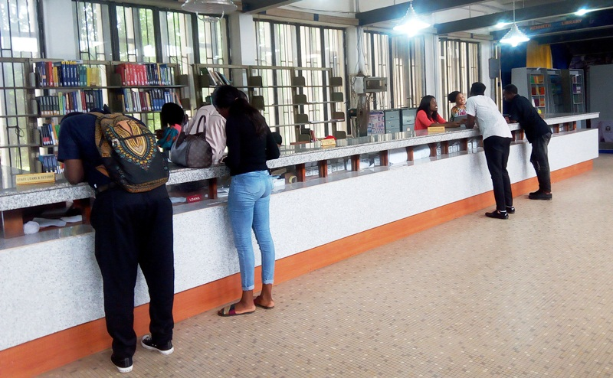**PICTURE GALLERY**

**Pic. 1: Main Entrance (Porters’ Lodge) Pic. 2: Circulation Desk**

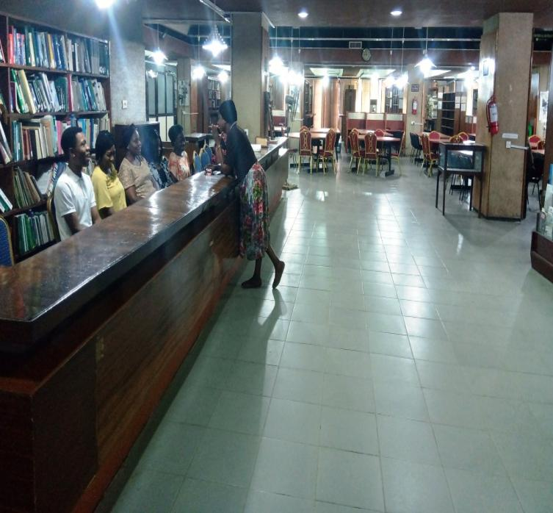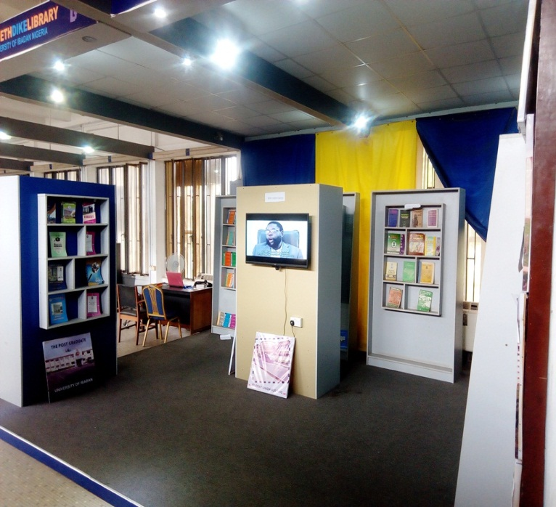

**Pic. 3: Display/Exhibition Gallery Pic. 4: Reference Section**

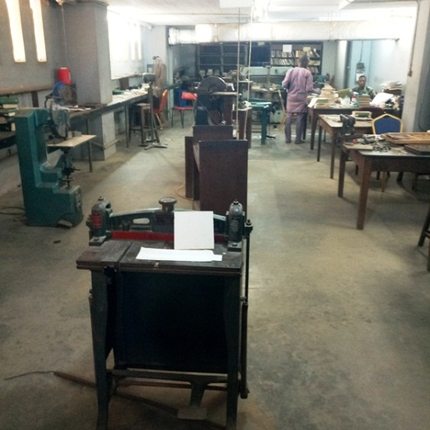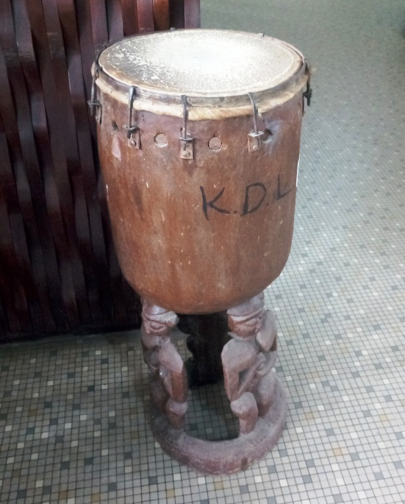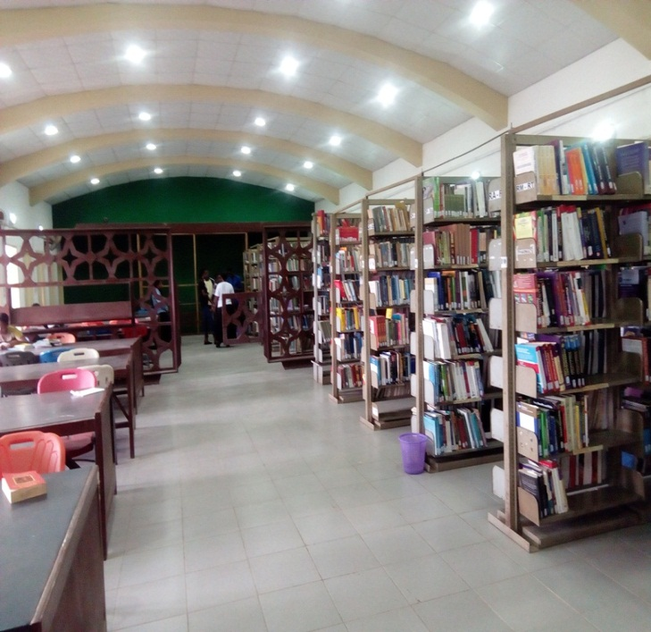**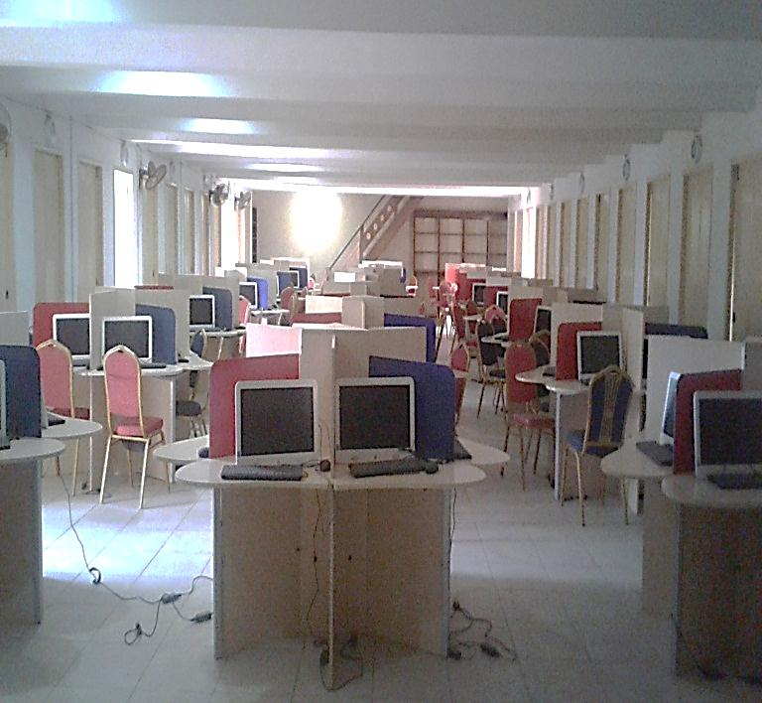Pic. 5: E- Research Facilities Pic. 6: Closed Access Collection**

**Pic. 7: Warning Drum Pic. 8: Bindery Section**

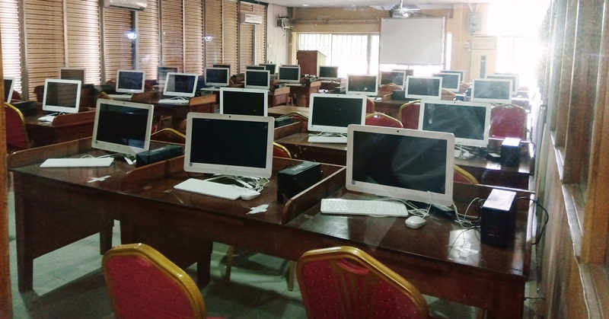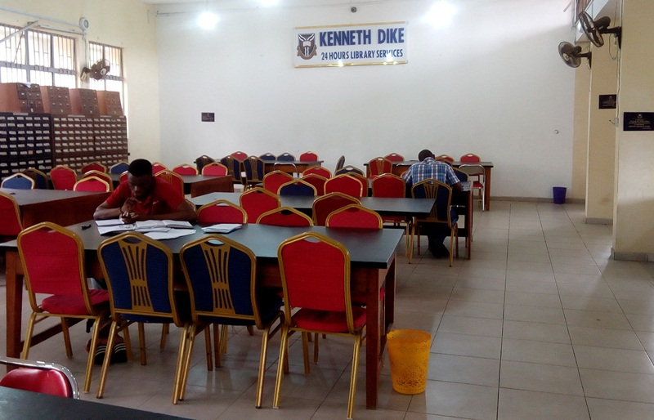**Pic. 9: 24-Hours Library Service Pic. 10: E-Classroom**

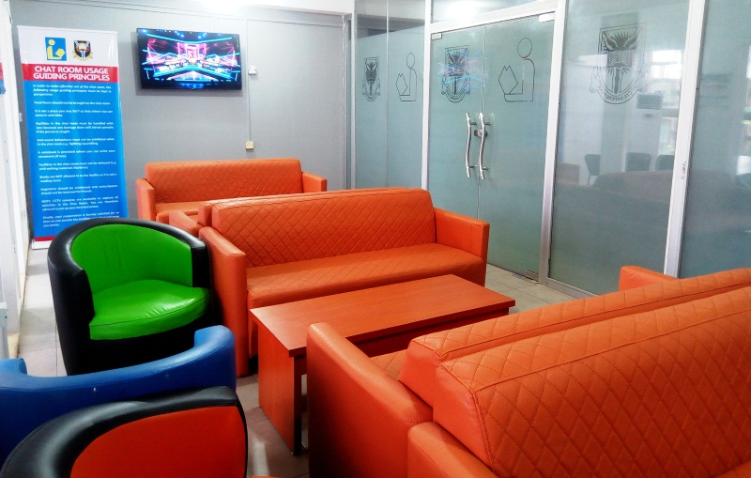

**Pic. 11: Chat Room**